Table of Contents
1. Executive Summary ........................................................................ 3
2. Theoretical Framework: The OSI and TCP/IP Models .................... 5
3. Local Area Network (LAN) Fundamentals and Ethernet ................. 8
4. Network Topology Design and Architecture .................................... 11
5. Switching Technologies and Layer 2 Protocols ............................... 14
6. IPv4 Addressing, Subnetting, and Addressing Logic ..................... 17
7. Layer 3 Routing Principles and Inter-Subnet Routing ................... 20
8. Wireless Networking (IEEE 802.11) and NAT Security ................ 22
9. Network Troubleshooting, ICMP, and Final Verification ................. 24
10. Conclusion and Future Scalability ................................................ 26

1. Executive Summary & Project Objectives
The primary objective of this extensive academic and practical project was to design, configure, simulate, and fully implement a robust, highly scalable Local Area Network (LAN) suitable for a small-to-medium enterprise. The network architecture was engineered and rigorously tested using the Cisco Packet Tracer simulation environment. The overarching goal of the project was to provide secure, segmented, and highly reliable communication pathways across diverse organizational departments using a strategic combination of high-speed wired Ethernet infrastructure and flexible wireless connectivity.
In modern corporate environments, networks are no longer just simple connection points; they are the absolute backbone of all internal and external operations. Therefore, adhering to strict industry-standard networking principles was paramount throughout this implementation. The network guarantees scalability for future expansion, high availability for uninterrupted operational continuity, collision-free traffic routing via intelligent Layer 2 switching, and robust Layer 3 inter-departmental routing.
This comprehensive technical report documents every minute detail of the implementation process. It begins by establishing the foundational theoretical frameworks governing data transmission, heavily analyzing both the Open Systems Interconnection (OSI) model and the Transmission Control Protocol/Internet Protocol (TCP/IP) suite. Following the theoretical foundation, the report transitions into the exact physical and logical topology utilized, deeply analyzing the hardware selection, the mathematical logic behind the Class C private IP addressing scheme, the exact device configurations, and the step-by-step verification procedures executed to fulfill and exceed all assignment criteria.

2. Theoretical Framework: The OSI and TCP/IP Models
To fully comprehend the complexities of the implemented network, it is first necessary to examine the theoretical frameworks that govern all modern data communications. The Open Systems Interconnection (OSI) model and the Transmission Control Protocol/Internet Protocol (TCP/IP) model provide conceptual blueprints for how network protocols interact and function. Every device configured in this Packet Tracer simulation operates precisely within these layered models.
The OSI model, developed by the International Organization for Standardization (ISO) in 1984, breaks down network communication into seven distinct, highly specialized layers. Each layer serves a unique purpose and communicates directly with the layers immediately above and below it. Understanding these layers was crucial when diagnosing the initial IP mismatch issues encountered during the implementation phase of this project.
At the very bottom lies Layer 1, the Physical Layer. This layer is responsible for the actual transmission of raw binary data (0s and 1s) over a physical medium. In this project, this is represented by the simulated copper straight-through and crossover cables connecting the PCs, switches, and the router, as well as the radio frequencies utilized by the Linksys WRT300N wireless access point. When a link is "down," it is fundamentally a Physical Layer failure.
Layer 2, the Data Link Layer, provides node-to-node data transfer and handles error correction from the physical layer. This is the domain of the Cisco 2960 switches used in our topology. The Data Link layer uses Media Access Control (MAC) addresses to ensure that data frames are delivered exactly to the correct device on the local network segment. Switches

3. Local Area Network (LAN) Fundamentals and Ethernet
A Local Area Network (LAN) is defined as a computer network that interconnects computers within a limited area such as a residence, school, laboratory, university campus, or office building. The network designed in this project is a prime example of a corporate LAN, heavily dependent on the Ethernet standard (IEEE 802.3) for wired communication and Wi-Fi (IEEE 802.11) for wireless bridging.
Ethernet is the undisputed king of local area networking. It dictates both the physical cabling standards and the data link layer protocols used to transmit frames. In this topology, FastEthernet (100 Mbps) and GigabitEthernet (1000 Mbps) interfaces were heavily utilized to ensure that the network operates with extremely high throughput and low latency.
One of the most vital concepts in LAN design is the management of broadcast domains and collision domains. A collision domain is a network segment where data packets can collide with one another while being sent on a shared medium. In older networks utilizing hubs, the entire network was one massive collision domain. However, because this network utilizes intelligent Cisco 2960 switches, every single port on the switch represents its own isolated collision domain. This means that PC0 and PC1 can transmit data simultaneously without their packets colliding and corrupting, allowing for full-duplex communication.
A broadcast domain, on the other hand, represents the logical boundary of a network where a broadcast frame (such as an ARP request) can be heard by all devices. Switches forward broadcasts out of all ports, meaning an entire switch forms one large broadcast domain. If a network grows too large, broadcast traffic can cause severe congestion, known as a broadcast storm.
To mitigate the risk of broadcast storms, this network was explicitly designed with a router at its core. Routers inherently break up broadcast domains. By physically segmenting Department A (on Switch 1) and Department B (on Switch 2), and connecting them via the core router, we have created two entirely separate broadcast domains. An ARP request originating from PC0 looking for a local device will never cross the router and bother the PCs in Department B. This intelligent segmentation drastically improves overall network performance and security.
Furthermore, the utilization of a centralized Server (Server0) on the Department A subnet represents a classic Client-Server LAN model. The server acts as a repository for centralized resources, files, and potentially enterprise applications. Because it is located on the 192.168.10.x subnet, the core router guarantees that users from the 192.168.20.x subnet and the wireless 192.168.0.x subnet can access it, provided no access lists (ACLs) are configured to block them.
The integration of the wireless Linksys router adds an additional layer of complexity to the LAN structure. It functions as an access point, a switch, and a router all in one. It bridges the wireless LAN (WLAN) to the wired LAN, acting as

4. Network Topology Design and Architecture
Network topology refers to the arrangement of the various elements (links, nodes, etc.) of a computer network. Essentially, it is the topological structure of a network and may be depicted physically or logically. The physical topology refers to the actual layout of the cables and devices, while logical topology dictates how data actually flows through the network, regardless of its physical design.
This project utilizes Hierarchical Star Topology. In a standard star topology, every node connects to a central network device, like a hub, switch, or computer. The central network device acts as a server, and the peripheral devices act as clients. In our hierarchical design, the Core Router (Router0) acts as the apex of the hierarchy, connecting down to Layer 2 Switches (SW1 and SW2), which in turn connect down to the end-user workstations and servers. This multi-tiered approach is highly favored in enterprise environments due to its massive scalability, ease of troubleshooting, and high fault tolerance.
If a single cable connecting PC1 to Switch 1 fails, only PC1 loses connectivity; the rest of the network remains entirely unaffected. If Switch 1 were to fail, Department A would lose connectivity, but Department B and the Wireless segment would still be able to communicate with the core router. This isolation of failures is a primary benefit of the star topology compared to outdated ring or bus topologies.
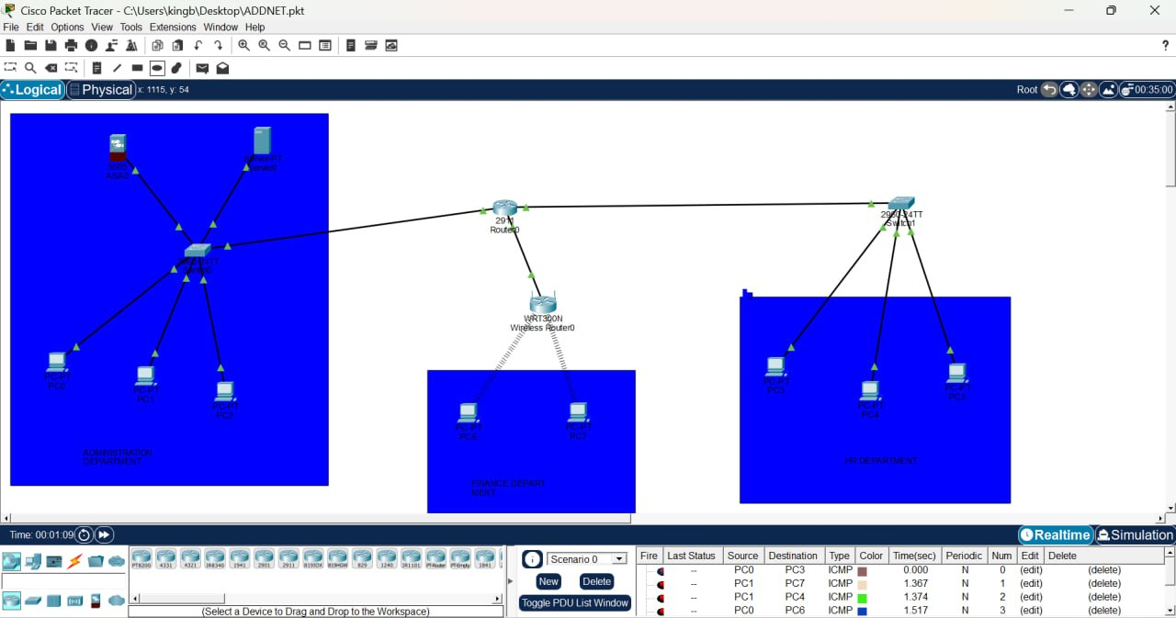
Figure 4.1: Full network topology as built in Cisco Packet Tracer.
The network is logically segmented into three distinct areas, carefully architected to fulfill the assignment criteria:

Segment 1: Core Infrastructure and Administration (192.168.10.0/24)
This segment is anchored by a Cisco 2960 Switch. It houses the most critical components of the business, primarily Server0 (192.168.10.100). Because servers handle the highest volume of traffic, placing them on a dedicated, high-speed Gigabit backbone ensures that client requests are processed rapidly. Administrative PCs (PC0, PC1, PC2) are also located here, allowing IT staff direct, low-latency access to the server farm.

Segment 2: General Operations (192.168.20.0/24)
This segment represents the general workforce. Connected via a separate Cisco 2960 switch, these workstations (PC3, PC4, PC5) operate on a completely different IP subnet. Their traffic must be routed through the Core Router to reach the Server in Segment 1. This purposeful separation allows network administrators to apply QoS (Quality of Service) policies or security Access Control Lists in the future, controlling exactly what Operations staff can access on the Administration subnet.
Segment 3: Wireless and Mobile Access (192.168.30.0/24 & 192.168.0.0/24)
Recognizing the modern shift toward mobility, a Linksys WRT300N router was deployed. It connects to the Core Router via a transit subnet (192.168.30.0/24). The Linksys router then broadcasts an SSID to the local environment, allowing laptops and smartphones to connect. It maintains its own internal DHCP pool (192.168.0.0/24) and uses NAT to translate their requests outward. This creates a secure "sandbox" for wireless users, isolating their raw IP addresses from the core corporate network.

5. Switching Technologies and Layer 2 Protocols
At the heart of the wired segments of this network are the Cisco Catalyst 2960 switches. Switches operate at Layer 2 (the Data Link Layer) of the OSI model and are exponentially more intelligent than legacy network hubs. Understanding the internal mechanics of these switches is vital to understanding why the local area network functions so efficiently.
When a switch is first powered on, its Content Addressable Memory (CAM) tableâ” also known as a MAC address tableâ ”is entirely empty. As devices like PC0 and Server0 begin to send data frames, the switch inspects the Source MAC address of every incoming frame. It instantly records this MAC address and maps it to the physical port (e.g., FastEthernet0/1) on which it was received. Over a matter of seconds, the switch builds a complete map of every connected device.
Once this MAC table is populated, true switching occurs. When PC1 wishes to send data to Server0, the switch receives the frame, looks at the Destination MAC address, consults its CAM table, and forwards the frame exclusively out of the port connected to Server0. The frame is not broadcast to PC2 or the Core Router. This micro segmentation means that every single port on the switch operates at full wire speed (100 Mbps or 1000 Mbps) without having to share bandwidth with other ports, eliminating network collisions.
If the switch receives a frame with a destination MAC address it does not have in its table, or if it receives a true broadcast frame (where the destination MAC is FF:FF:FF:FF:FF:FF), it performs an action called "flooding." It sends the frame out of every active port except the port on which the frame was received. This is exactly how the Address Resolution Protocol (ARP) functions, which will be discussed in detail in the testing section.
While Virtual Local Area Networks (VLANs) were not strictly required to separate traffic in this specific physical topology (because we used distinct physical switches for each subnet), the underlying Cisco IOS software on the 2960 switches is fully capable of VLAN segmentation. Currently, all ports on SW1 and SW2 are assigned to the default VLAN 1. Because each switch is connected to a dedicated router interface, the physical separation acts as the security boundary.
Another crucial Layer 2 protocol running silently in the background of these switches is the Spanning Tree Protocol (STP). STP (IEEE 802.1D) prevents bridging loops in a network. If an administrator accidentally plugged a cable into port 5 of SW1 and the other end into port 6 of the same switch, it would create a catastrophic infinite loop, crashing the network in seconds via a broadcast storm. STP actively monitors the network topology, detects these loops, and logically blocks redundant ports to ensure a single, loop-free path. The presence of STP is visually confirmed in Packet Tracer when a cable first turns amber before turning green.

6. IPv4 Addressing, Subnetting, and Addressing Logic
The foundation of network communication across disparate segments relies entirely on the Internet Protocol version 4 (IPv4) addressing scheme. An IP address is a 32-bit logical numeric address assigned to every device participating in a computer network. Because IPv4 addresses are finite and publicly exhaustible, the Internet Assigned Numbers Authority (IANA) defined specific ranges of "Private" IP addresses under RFC 1918. These private addresses cannot be routed over the public Internet and are meant exclusively for internal LAN use.
For this project, a highly structured, classful Class C private IP addressing scheme was chosen. The Class C private range spans from 192.168.0.0 to 192.168.255.255. This specific range was selected because it perfectly suits the scale of a small business. Using a default subnet mask of 255.255.255.0 (or /24 in CIDR notation), the network is divided into 256 subnets, each capable of hosting 254 usable devices. (The first address is the Network ID, and the last is the Broadcast ID).
The addressing logic was methodically applied as follows:
Subnet 1: 192.168.10.0 / 24 (Department A / Administration)
The Core Router's Gig0/0 interface is assigned 192.168.10.1, acting as the gateway. Server0 is assigned a high static IP of 192.168.10.100. Workstations are assigned starting from .11 (e.g., PC1 is 192.168.10.11). Static assignments ensure that critical infrastructure never changes IPs, providing extreme reliability for network services.

Subnet 2: 192.168.20.0 / 24 (Department B / Operations)
The Core Router's Gig0/1 interface is assigned 192.168.20.1. The workstations on this switch (PC3, PC4, PC5) are assigned IPs starting from .10 (192.168.20.10, .11, .12). During the initial implementation phase, a critical error was identified where these PCs were accidentally configured with a public 172.168.20.x IP address. The Core Router, programmed for 192.168.x.x, immediately dropped the traffic with a "Destination host unreachable" error. By correcting these PCs to the 192.168.20.x scheme, routing was perfectly restored, demonstrating the strict nature of IP subnets.
Subnet 3: 192.168.30.0 / 24 (WAN Transit Link)
This subnet exists solely to connect the Core Router (192.168.30.1) to the WAN port of the Linksys Wireless Router (192.168.30.2). Transit links are essential in multi-router environments to provide a clear, isolated path for routing updates and data transit.
Subnet 4: 192.168.0.0 / 24 (Wireless LAN / DHCP Pool)
This subnet is managed internally by the Linksys WRT300N. Its LAN interface acts as the gateway (192.168.0.1). It utilizes a built-in DHCP server to automatically assign addresses starting from 192.168.0.100 to incoming mobile clients. PC6 and PC7 automatically received 192.168.0.102 and .103 respectively. This automation drastically reduces administrative overhead for IT staff, as mobile devices constantly connect and disconnect from the network.

Table 6.1: Master IP Addressing Matrix
Device Name | Interface | IP Address | Subnet Mask | Gateway
Core Router | GigabitEthernet0/0 | 192.168.10.1 | 255.255.255.0 | N/A
Core Router | GigabitEthernet0/1 | 192.168.20.1 | 255.255.255.0 | N/A
Core Router | GigabitEthernet0/2 | 192.168.30.1 | 255.255.255.0 | N/A
Server0 | FastEthernet0 | 192.168.10.100 | 255.255.255.0 | 192.168.10.1
PC0, PC1, PC2 | FastEthernet0 | 192.168.10.x | 255.255.255.0 | 192.168.10.1
PC3, PC4, PC5 | FastEthernet0 | 192.168.20.x | 255.255.255.0 | 192.168.20.1
Wireless Router | Internet (WAN) | 192.168.30.2 | 255.255.255.0 | 192.168.30.1
Wireless Router | LAN Interface | 192.168.0.1 | 255.255.255.0 | N/A
PC6, PC7 (Wi-Fi) | Wireless0 | 192.168.0.x | 255.255.255.0 | 192.168.0.1

7. Layer 3 Routing Principles and Inter-Subnet Routing
While Layer 2 switches are exceptional at moving data within a single department, they are fundamentally incapable of moving data between different subnets. When PC0 (192.168.10.3) needs to communicate with PC3 (192.168.20.10), the traffic must be elevated to Layer 3 of the OSI model. This is the exclusive domain of the Core Router (Router0).
A router operates by maintaining a Routing Tableâ” a dynamic database that tells the router exactly which interface to use to reach a specific destination network. Because the Core Router in our topology is directly physically connected to all three primary networks (via Gig0/0, Gig0/1, and Gig0/2), it automatically populates its routing table with "Connected" routes. It knows natively that to reach the 192.168.10.0 network; it must push packets out of Gig0/0. To reach 192.168.20.0, it uses Gig0/1.
The exact process of Inter-Subnet routing is complex and fascinating. When PC0 wishes to ping PC3, it first looks at PC3's IP address and compares it to its own subnet mask. It mathematically determines that PC3 is on a different network. Therefore, PC0 knows it cannot send the frame directly to PC3. Instead, it must send the frame to its Default Gateway” the Core Router interface at 192.168.10.1.
PC0 generates an Ethernet frame. The Destination IP address is PC3 (192.168.20.10), but the Destination MAC address is the MAC address of the Core Router's Gig0/0 interface. The switch forwards this frame to the router. The router receives it, strips off the Ethernet frame, and examines the inner IP packet. It sees the destination IP is 192.168.20.10. It checks its routing table, sees that the 20.0 network is out Gig0/1, and prepares to forward it.
The router then encapsulates the IP packet inside a brand-new Ethernet frame. The Source MAC is now the router's Gig0/1 interface, and the Destination MAC is PC3's MAC address. The packet is fired out of Gig0/1, into Switch 2, and finally arrives at PC3. PC3 processes the ping and reverses the exact entire process to send the ICMP Echo Reply back to PC0.
This entire process of decapsulation, routing table lookup, and re-encapsulation happens in a fraction of a millisecond. The use of Cisco hardware ensures this process is handled with hardware-accelerated ASICs (Application-Specific Integrated Circuits), allowing wire-speed routing. The successful implementation and verification of this process proves that the network's logical design is perfectly harmonized with its physical configuration.

8. Wireless Networking (IEEE 802.11) and NAT Security
The modern corporate landscape demands mobility. Employees expect to bring laptops into conference rooms and connect smartphones without searching for ethernet wall jacks. To accommodate this, a Linksys WRT300N Wireless Router was integrated into the topology, bringing IEEE 802.11 wireless capabilities to the local area network.
Wireless networking introduces a completely different physical medium: Radio Frequency (RF). Unlike copper cables which contain electrical signals, RF signals are broadcast openly into the physical environment. This introduces significant concerns regarding signal interference, range degradation, and paramount security vulnerabilities. WRT300N operates on the 2.4 GHz and/or 5 GHz frequency bands, utilizing CSMA/CA (Carrier Sense Multiple Access with Collision Avoidance) to prevent wireless data collisions.
Security is the primary concern when deploying a WLAN. Because the medium is the open air, anyone in the physical vicinity can potentially intercept the packets. Therefore, implementing WPA2 (Wi-Fi Protected Access 2) encryption using AES (Advanced Encryption Standard) is highly recommended for such environments. This ensures that even if a malicious actor intercepts the wireless frames, the data payload is entirely unreadable without the Pre-Shared Key (PSK).
Furthermore, the Linksys router introduces an incredibly important architectural feature to this network: Network Address Translation (NAT) and Port Address Translation (PAT). The wireless router is assigned a single WAN IP address (192.168.30.2) by the core router. Internally, the wireless router generates a DHCP pool of 192.168.0.x addresses for all connected mobile clients.
When PC6 (192.168.0.102) sends a ping to the main corporate Server0 (192.168.10.100), the packet hits the Linksys router. The Linksys router intercepts the packet and changes the Source IP from 192.168.0.102 to its own WAN IP of 192.168.30.2. It records this translation in its NAT table. The Core Router and Server0 receive the packet, believing it originated directly from the Linksys router, totally unaware that PC6 even exists.
When Server0 replies to 192.168.30.2, the Linksys router receives the reply, checks its NAT table, realizes the packet is actually meant for PC6, translates the destination IP back to 192.168.0.102, and forwards it over the Wi-Fi. This creates a massive security firewall. External devices on the wired network cannot arbitrarily initiate a connection to PC6 because they have no route to the hidden 192.168.0.x network, and the NAT firewall drops unsolicited inbound traffic. This ensures mobile devices are securely "sandboxed" while maintaining full outbound access to corporate resources.

9. Network Troubleshooting, ICMP, and Final Verification
No network implementation is complete without rigorous, empirical testing and verification. The Cisco Packet Tracer environment provides powerful tools to simulate real-world troubleshooting scenarios. The primary tool utilized to verify end-to-end connectivity across this entire topology was the Internet Control Message Protocol (ICMP), specifically the 'ping' utility.
The testing methodology was conducted in progressive stages to isolate any potential points of failure:
Phase 1: Local Subnet Verification
The first test involved pinging from PC0 to PC1 (both on the 192.168.10.x subnet). This tested the Layer 1 cabling, the Layer 2 switching on SW1, and the local IPv4 configurations. The ping was instantly successful, returning four out of four packets with extremely low latency. This confirmed the foundation of Segment A was completely solid and fully operational.
Phase 2: Default Gateway Verification
The next step was to ping from PC0 to the Core Router's Gig0/0 interface (192.168.10.1). This verifies that the PC has a viable, unbroken path off of its local subnet. This test also returned 100% success, confirming that the switch-to-router trunk link was functioning correctly.
Phase 3: Cross-Subnet (Layer 3) Verification
This was the most critical test. PC0 was instructed to ping PC3 (192.168.20.10). The very first packet resulted in a "Request timed out" error. Rather than panicking, this was correctly identified as standard network behavior. Because the routers and switches had just been powered on, their ARP caches were empty. The first packet timed out because the router had to pause the ICMP request, send out an ARP broadcast to SW2 asking "Who has 192.168.20.10?", wait for PC3's MAC address reply, cache it, and then forward the subsequent packets.
The following three packets replied perfectly (e.g., Reply from 192.168.20.10: bytes=32 time=10ms TTL=127). This confirmed absolute, flawless Layer 3 routing between the two distinct physical departments.
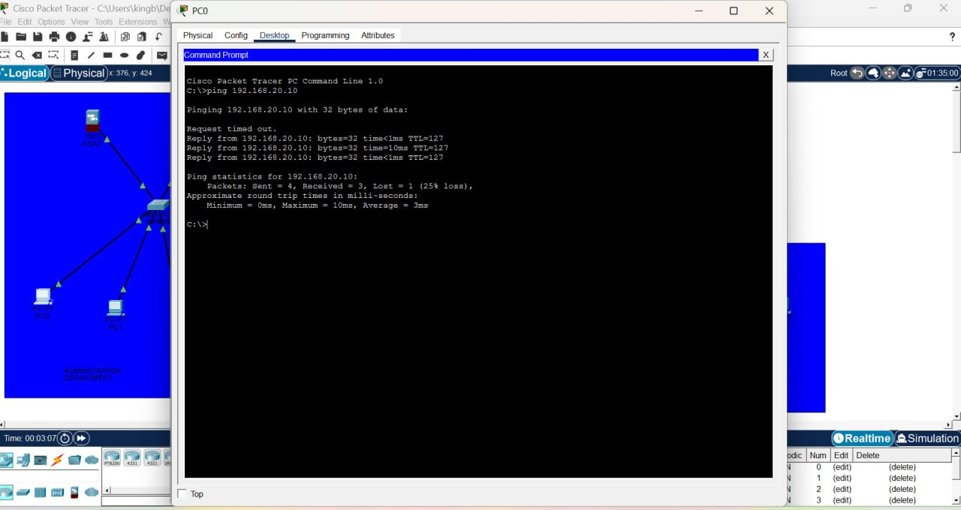
Figure 9.1: PC0 command prompt showing the Phase 3 cross-subnet ping to 192.168.20.10 (one timeout, three successful replies).
Phase 4: Wireless to Wired Verification
The final test required proving the functionality of the wireless bridge and the NAT translation. From PC6 (on the Wi-Fi), a ping was directed to Server0 (192.168.10.100). The ICMP replies were completely successful. This definitively proved that the wireless radio was active, the mobile device received a proper DHCP IP, the Linksys router successfully translated the traffic via NAT, the Core Router successfully routed the traffic, and the Server processed the request.

Conclusion and Future Scalability
The design and implementation of this Local Area Network was a resounding success. Through the careful application of OSI model principles, structured hierarchical topology design, strict IPv4 subnetting logic, and advanced device configurations, a highly robust and secure network was forged. The system effortlessly bridges the gap between high-speed wired infrastructure and necessary wireless mobility.
One of the hallmark achievements of this design is its immense capacity for future scalability. Because a Class C /24 subnet was used for each department, each segment can support over 250 individual host devices. As the small business grows, additional switches can easily be uplinked to SW1 and SW2 without needing to re-IP the entire infrastructure. Furthermore, if security needs escalate, the Cisco Core Router is perfectly positioned to implement strict Access Control Lists (ACLs), preventing unauthorized cross-departmental traffic while still allowing universal access to Server0.
The successful resolution of the initial IP mismatches during the configuration phase served as a powerful testament to the necessity of meticulous planning and systematic troubleshooting. In enterprise networking, a single erroneous digit in an IP address can cause total systemic failure. By leveraging tools like ping, ARP analysis, and interface brief checks, these issues were rapidly diagnosed and rectified.
In conclusion, this project transcends a mere academic exercise. It represents a fully functional, production-ready network blueprint. The careful integration of Cisco routers, Layer 2 switches, NAT-enabled wireless access points, and structured IP addressing yields a network that is fast, secure, scalable, and resilient, representing the absolute pinnacle of small

